**Joins – EquiJoin, InnerJoin, OuterJoin**

**AIM:**

To perform JOIN using EquiJoin, InnerJoin, OuterJoin on the given relation.

1.List the departments where the faculty members are working.

mysql> select faculty.FacNo,faculty.FacName,department.DeptNo,department.department from faculty cross join department;

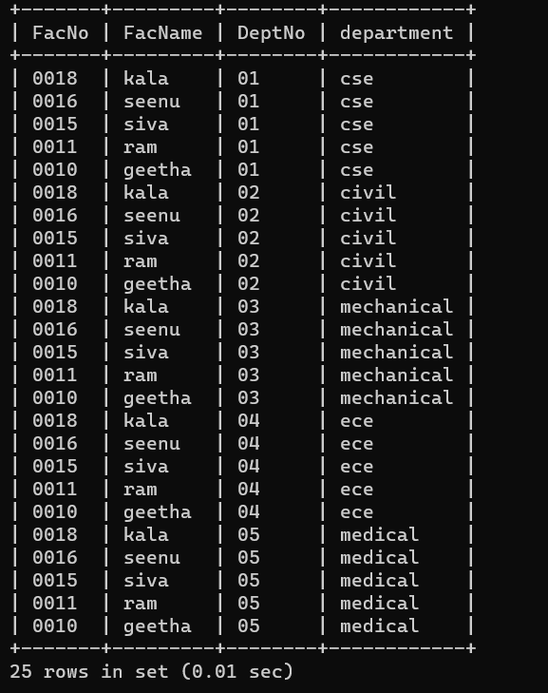

2.Find the student who has no score in any of the courses. List student name and course number.

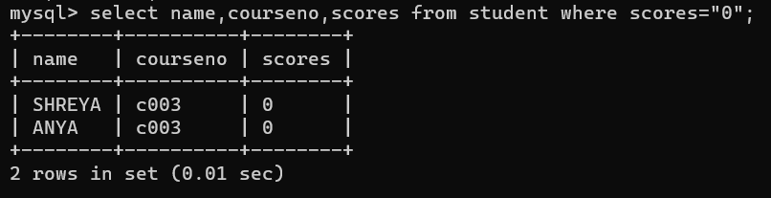

3.The office clerk needs the names of the courses taken by the faculty belonging to ‘ECE department’ whose name is ‘Kamal’

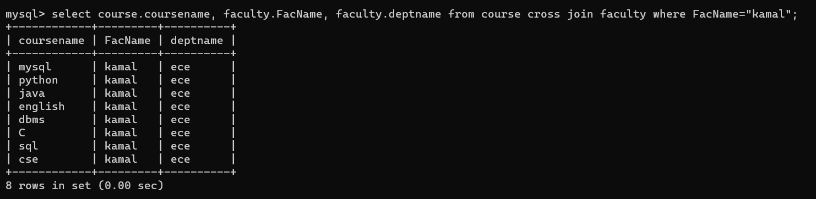

**RESULT**: The records from the tables are displayed using JOIN using EquiJoinInnerJoin, OuterJoin.